1. **Create a simple page to demonstrate the usage of necessary html tags. The page should contains minimum places and their description (image and description). You can show your own creativity which will be evaluated accordingly.**

**Explanation of the HTML Tags Used:**

1. **<!DOCTYPE html>**: Declares the document type and version of HTML being used
2. **<html>**: Defines the start of the HTML document.
3. **<head>**: Contains meta-information about the document, including the title and link to styles.
4. **<meta name="viewport">**: Ensures the page is responsive and adjusts to different screen sizes.
5. **<title>**: Specifies the title of the page, which appears in the browser tab.
6. **<style>**: Contains internal CSS to style the webpage.
7. **<body>**: Contains the main content of the webpage.
8. **<header>**: Contains introductory content, such as the title and a short description.
9. **<section>**: Groups content together—in this case, the places and their descriptions.
10. **<article>**: Represents each individual place with an image and description.
11. **<img>**: Displays an image on the page. The src attribute defines the source of the image, and alt provides alternative text.
12. **<h1>**: Used for the title of each place.
13. **<p>**: Represents a paragraph of text, used here for the description of each place.
14. **<footer>**: Contains footer content, such as copyright information or other relevant links.

<!DOCTYPE html>

<html lang="en">

<head>

<meta charset="UTF-8">

<meta name="viewport" content="width=device-width, initial-scale=1.0">

<title>Creative Place Descriptions</title>

<style>

body {

font-family: Arial, sans-serif;

background-color: #f4f4f4;

margin: 0;

padding: 0;

}

header {

background-color: #4CAF50;

color: white;

text-align: center;

padding: 20px;

}

section {

display: flex;

flex-wrap: wrap;

justify-content: center; }

article {

border-radius: 8px;

}

h2 {

color: #0c0c0c; }

p {

color: #000000;

}

</style>

</head>

<body>

<header>

<h1>Explore Beautiful Places</h1>

<p>Click on the images to explore more about these beautiful places.</p>

</header>

<section>

<article>

<h2>Sunny Beach</h2>

<p>Sunny Beach is known for its golden sands and crystal-clear waters. A perfect place to relax and enjoy the sun. </p>

</article>

<article>

<h2>City Skyline</h2>

<p>The City Skyline is famous for its towering buildings and vibrant city life, offering plenty of entertainment options.</p>

</article>

</section>

</body>

</html>

Output:

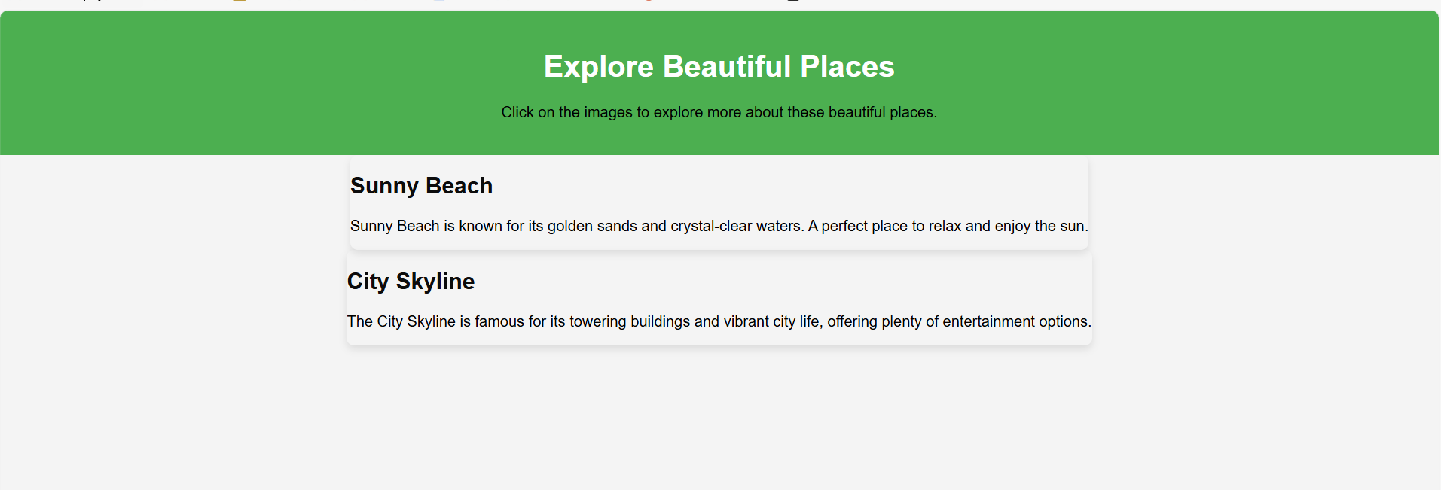

1. **Create a page that shows the course structure of B.Sc.CSIT using List. Also create organizational structure of College of Applied Business.**

<!DOCTYPE html>

<html lang="en">

<head>

<meta charset="UTF-8">

<meta name="viewport" content="width=device-width, initial-scale=1.0">

<title>Course & Organization Structure</title>

<style>

table {

border-collapse: collapse;

margin: 10px auto;

text-align: center;

}

table, th, td {

border: 1px solid black;

}

</style>

</head>

<body>

<h2>CSIT Course Structure</h2>

<ol>

<li>First Semester</li> <ul>

<li>Introduction to IT</li>

<li>C Programming</li>

<li>Digital Logic</li>

<li>Mathematics</li>

<li>Physics</li> </ul>

</ol>

<h2>College Organization Structure</h2>

<table>

<tr><th>College Management Committee</th></tr>

</table>

<div class="arrow">&#8595;</div>

<table>

<tr><th>Chairman</th></tr>

</table>

<div class="arrow">&#8595;</div>

<table>

<tr><th>Principal</th></tr>

</table>

<div class="arrow">&#8595;</div>

<table>

<tr><th>Vice Principal</th></tr>

</table>

<div class="arrow">&#8595;</div>

<table>

<tr>

<th>General Administration</th>

<th>Academic Administration</th>

</tr>

<tr>

<td>Administration Section</td>

<td>BSc. CSIT Department</td>

</tr>

<tr>

<td>Account Section</td>

<td>BIM Department</td>

</tr>

<tr>

<td>Library Section</td>

<td>BBA Department</td>

</tr>

<tr>

<td>Exam Section</td>

<td></td>

</tr>

</table>

</body>

</html>

Output: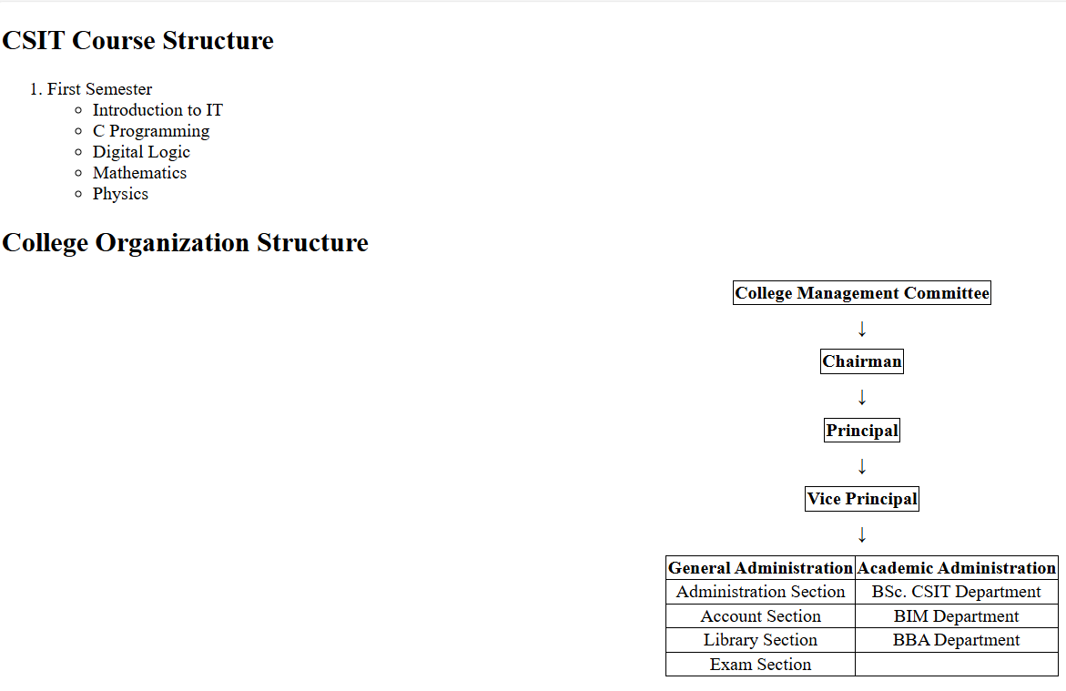

1. **Create a User registration form with necessary fields.**

<!DOCTYPE html>

<html lang="en">

<head>

<meta charset="UTF-8" />

<meta name="viewport" content="width=device-width, initial-scale=1.0" />

<title>Registration Form</title>

</head>

<body>

<h1>Registration Form</h1>

<form>

<label for="firstName">First Name:</label><br />

<input type="text" name="Firstname" />

<br />

<label for="lasttName">Last Name:</label><br />

<input type="text" name="Lastname" />

<br />

<label for="email">Email:</label><br />

<input type="text" name="email" />

<br />

<label for="password">Password:</label><br />

<input type="password" name="password" />

<br />

<input type="radio" name="gender" id="Male" />Male

<input type="radio" name="gender" id="Female" />Female

<br />

<input type="Submit" name="submit" />

</form>

</body>

</html>

Output:

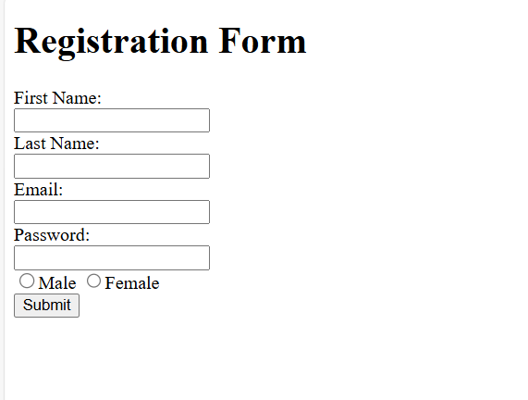

1. **Using CSS and HTML design following layout.**

<!DOCTYPE html>

<html lang="en">

<head>

<meta charset="UTF-8">

<meta name="viewport" content="width=device-width, initial-scale=1.0">

<title>Flexbox Table Layout</title>

<style>

.container {

display: flex;

flex-direction: column;

width: 100%;

max-width: 400px;

margin: 20px auto;

border: 1px solid black;

box-sizing: border-box;

}

.row {

display: flex;

width: 100%;

}

.cell {

display: flex;

justify-content: center;

align-items: center;

border: 1px solid black;

box-sizing: border-box;

height: 50px;

}

.cell-1 {

flex: 1 1 100%;

}

.cell-2, .cell-3, .cell-4 {

flex: 1 1 33.33%;

}

.cell-5, .cell-6 {

flex: 1 1 50%;

}

</style>

</head>

<body>

<div class="container">

<div class="row">

<div class="cell cell-1">1</div>

</div>

<div class="row">

<div class="cell cell-2">2</div>

<div class="cell cell-3">3</div>

<div class="cell cell-4">4</div>

</div>

<div class="row">

<div class="cell cell-5">5</div>

<div class="cell cell-6">6</div>

</div>

</div>

</body>

</html>

Output:

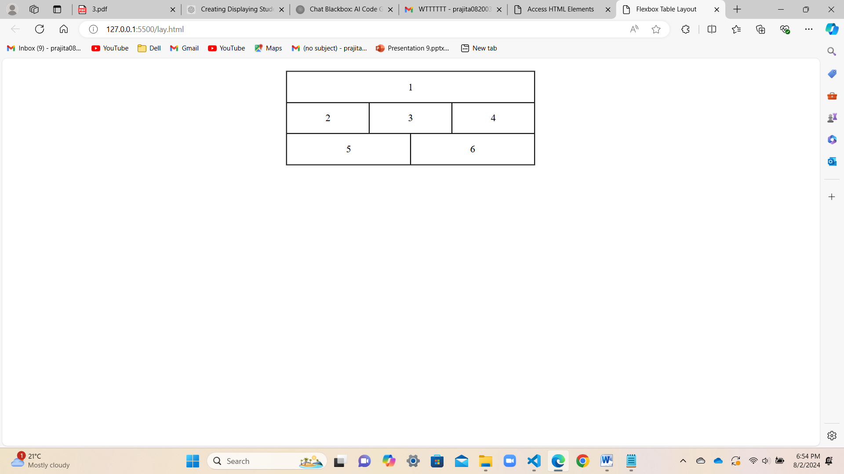

1. **Design your class routine using appropriate css.**

<!DOCTYPE html>

<html lang="en">

<head>

<meta charset="UTF-8">

<meta name="viewport" content="width=device-width, initial-scale=1.0">

<title>Class Routine</title>

<style>

body {

font-family: Arial, sans-serif; }

table {

width: 100%;

border-collapse: collapse;

margin-bottom: 20px;

}

th, td {

border: 1px solid #ddd;

padding: 8px;

text-align: center;

}

th {

background-color: #f2f2f2;

}

.break {

font-style: italic;

}

</style>

</head>

<body>

<table>

<thead>

<tr>

<th>Time</th>

<th>Sunday</th>

<th>Monday</th>

<th>Tuesday</th>

<th>Wednesday</th>

<th>Thursday</th>

<th>Friday</th>

</tr>

</thead>

<tbody>

<tr>

<td>7:00 am - 9:00 am</td>

<td>Cryptography</td>

<td>Java</td>

<td>Cryptography</td>

<td>DAA</td>

<td>Java</td>

<td>DAA</td>

</tr>

<tr>

<td>9:00 am - 9:30 am</td>

<td class="break" colspan="6">Break</td>

</tr>

<tr>

<td>9:30 am - 11:30 am</td>

<td>SAD</td>

<td>Devops</td>

<td>SAD</td>

<td>Simulation and Modeling</td>

<td>Presentation</td>

<td>Simulation and Modeling</td>

</tr>

<tr>

<td>11:30 am - 1:30 pm</td>

<td>Image Processing</td>

<td>-</td>

<td>Image Processing</td>

<td>Web Technology</td>

<td>-</td>

<td>Web Technology</td>

</tr>

</tbody>

</table>

</body>

</html>

Output:

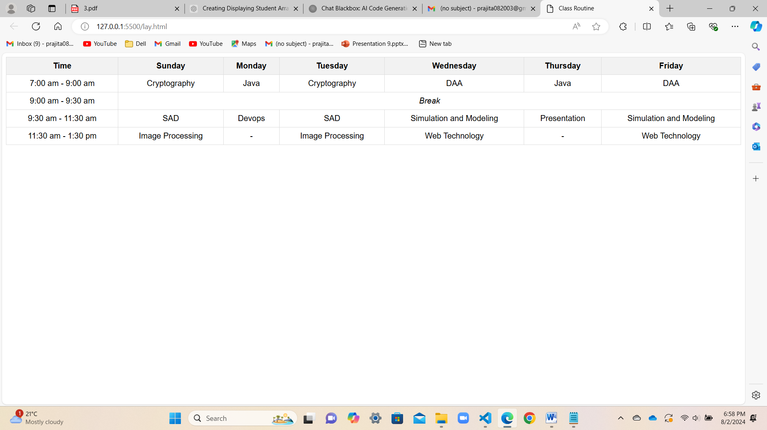

1. **Write a code for the position relative, absolute, fixed and make html page using css position.**

<!DOCTYPE html>

<html lang="en">

<head>

<meta charset="UTF-8">

<meta name="viewport" content="width=device-width, initial-scale=1.0">

<title>CSS Positioning</title>

<style>

body {

font-family: Arial, sans-serif;

margin: 0;

padding: 0;

height: 2000px;

}

.container {

width: 100%;

height: 300px;

background-color: #f0f0f0;

position: relative;

border: 1px solid #ccc;

margin-bottom: 20px;

}

.relative-box {

position: relative;

width: 100px;

height: 100px;

background-color: #ffcc00;

top: 20px;

left: 20px;

}

.absolute-box {

position: absolute;

width: 100px;

height: 100px;

background-color: #ff6666;

top: 20px;

right: 20px;

}

.fixed-box {

position: fixed;

width: 100px;

height: 100px;

background-color: #66ccff;

top: 290px;

right: 20px;

}

</style>

</head>

<body>

<div class="container">

<div class="relative-box">Relative</div>

<div class="absolute-box">Absolute</div>

</div>

<div class="fixed-box">Fixed</div>

</body>

</html>

Output:

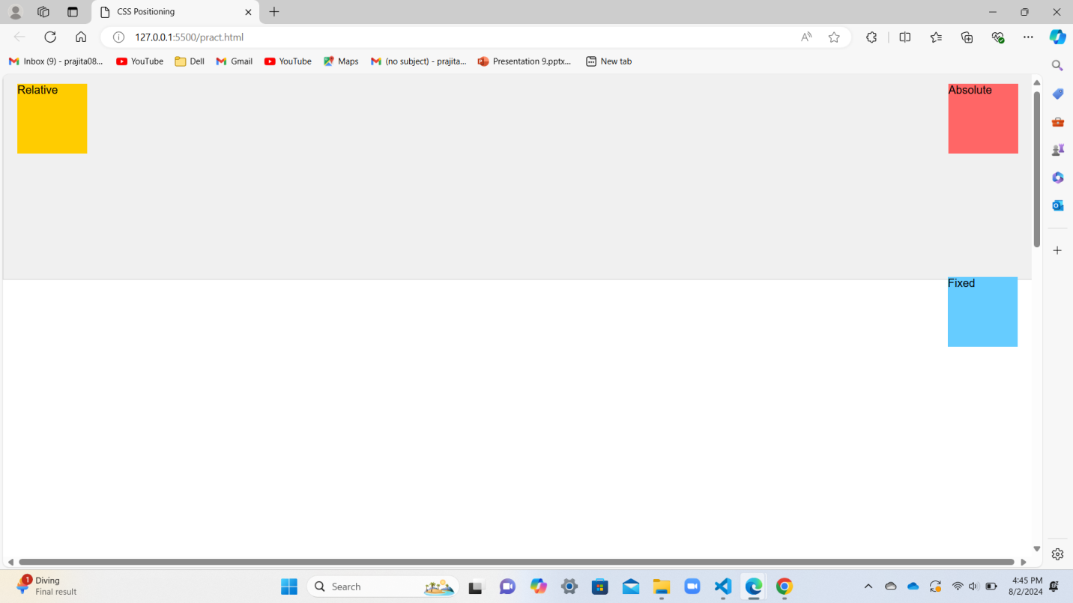

1. **Using CSS design attractive 3D effect buttons.**

<!DOCTYPE html>

<html lang="en">

<head>

<meta charset="UTF-8">

<meta name="viewport" content="width=device-width, initial-scale=1.0">

<title>3D Effect Buttons</title>

<style>

body {

display: flex;

justify-content: center;

align-items: center;

height: 100vh;

margin: 0;

background-color: #f0f0f0;

font-family: Arial, sans-serif;

}

.btn {

background-color: #13415f;

border: none;

color: white;

padding: 15px 30px;

font-size: 16px;

margin: 10px;

cursor: pointer;

border-radius: 10px;

transition: all 0.3s ease;

box-shadow: 0 5px #2980b9;

}

.btn:hover {

background-color: #bb6cd3;

}

.btn:active {

transform: translateY(4px);

box-shadow: 0 2px #2980b9;

}

</style>

</head>

<body>

<button class="btn">3D Button 1</button>

<button class="btn">3D Button 2</button>

<button class="btn">3D Button 3</button>

</body>

</html>

Output:

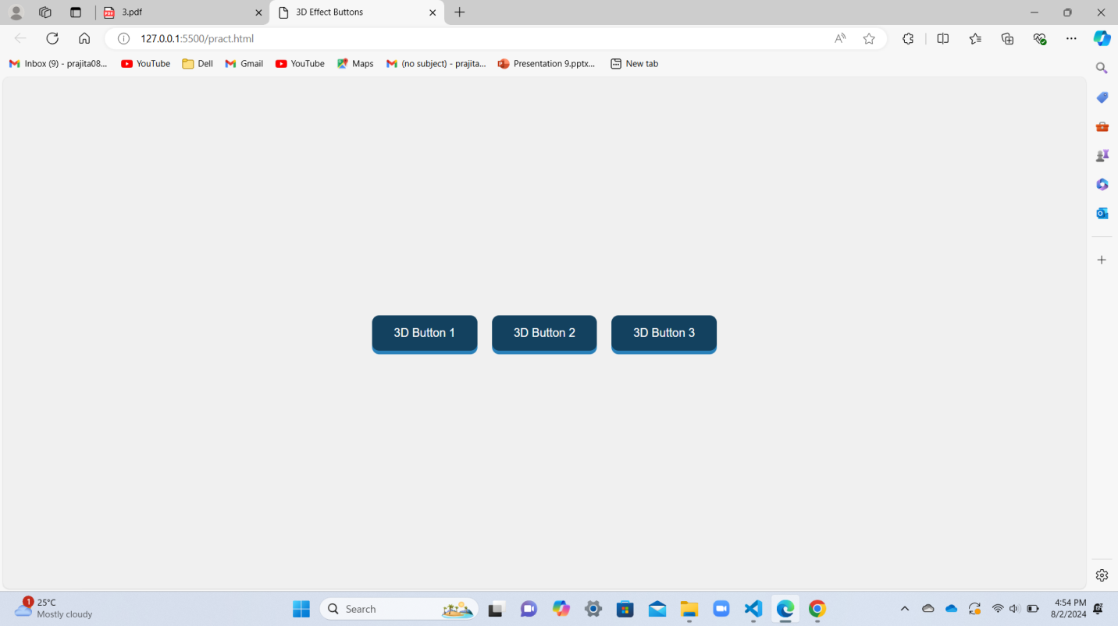

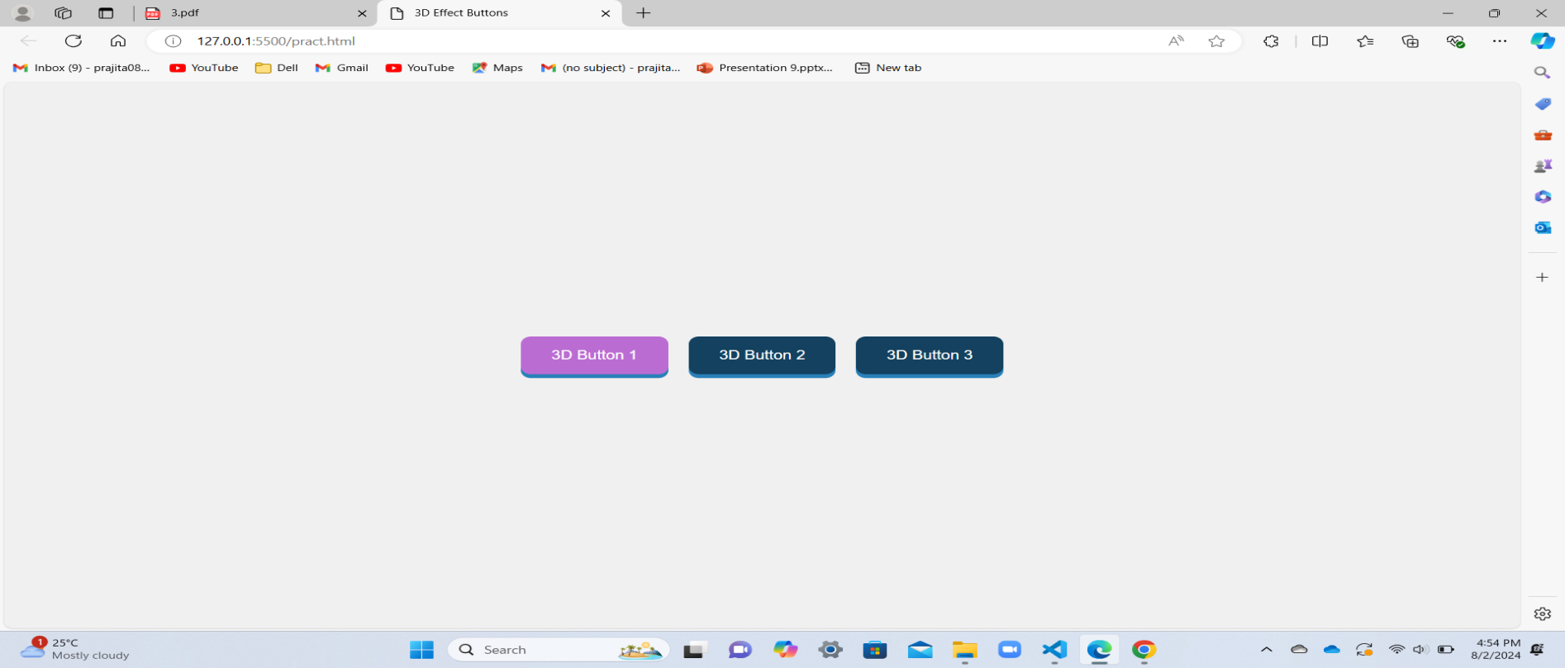

1. **Create an array Student that contains information of student and display the array.**

<!DOCTYPE html>

<html lang="en">

<head>

<meta charset="UTF-8">

<meta name="viewport" content="width=device-width, initial-scale=1.0">

<title>Student Array Example</title>

</head>

<body>

<h1>Student Information</h1>

<div id="student-list"></div>

<script>

const students = [

{ name: "Alice", age: 15, grade: "10th" },

{ name: "Bob", age: 16, grade: "11th" },

{ name: "Charlie", age: 15, grade: "10th" }

];

function displayStudents()

{

const studentListDiv = document.getElementById('student-list');

studentListDiv.innerHTML = '';

const ul = document.createElement('ul');

students.forEach(student => {

const li = document.createElement('li');

li.textContent = `Name: ${student.name}, Age: ${student.age}, Grade: ${student.grade}`;

ul.appendChild(li);

});

studentListDiv.appendChild(ul);

}

displayStudents();

</script>

</body>

</html>

Output:

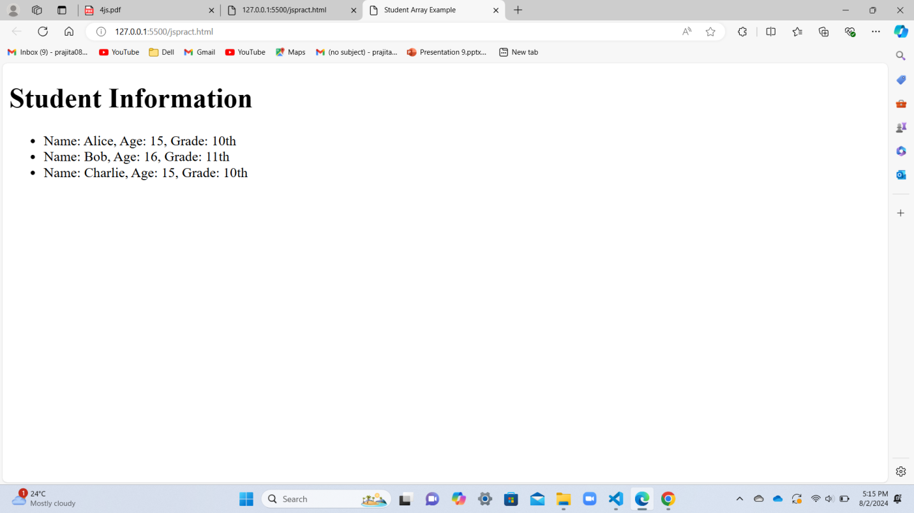

1. **Create a user registration form that takes personal details: Name , Phone , Email ,Address ,DOB ,College, faculty . Qualification, Hobbies and Additional information. Apply necessary validation using JavaScript. Apply jQuery effects on the document.**

<!DOCTYPE html>

<html lang="en">

<head>

<meta charset="UTF-8">

<meta name="viewport" content="width=device-width, initial-scale=1.0">

<title>User Registration Form</title>

<style>

form {

max-width: 500px;

margin: auto;

padding: .2rem;

border: 1px solid #ccc;

border-radius: 8px;

}

.form-group {

margin-bottom: 1rem;

}

h2{

text-align: center;

}

label {

display: block;

margin-bottom: .5rem;

}

input, textarea, select {

width: 100%;

padding: .5rem;

box-sizing: border-box;

height: 5px;

}

.error {

color: red;

font-size: .875rem;

margin-top: .1rem;

display: none;

}

.success {

color: green;

font-size: .775rem;

margin-top: .5rem;

display: none;

}

.highlight {

border: 2px solid #ff0000;

}

</style>

<script src="https://code.jquery.com/jquery-3.6.0.min.js"></script>

</head>

<body>

<h2>User Registration Form</h2>

<form id="registration-form">

<div class="form-group">

<label for="name">Name:</label>

<input type="text" id="name" name="name">

<div id="name-error" class="error"></div>

</div>

<div class="form-group">

<label for="phone">Phone:</label>

<input type="text" id="phone" name="phone">

<div id="phone-error" class="error"></div>

</div>

<div class="form-group">

<label for="email">Email:</label>

<input type="email" id="email" name="email">

<div id="email-error" class="error"></div>

</div>

<div class="form-group">

<label for="address">Address:</label>

<textarea id="address" name="address"></textarea>

<div id="address-error" class="error"></div>

</div>

<div class="form-group">

<label for="dob">Date of Birth:</label>

<input type="date" id="dob" name="dob">

<div id="dob-error" class="error"></div>

</div>

<div class="form-group">

<label for="college">College:</label>

<input type="text" id="college" name="college">

<div id="college-error" class="error"></div>

</div>

<div class="form-group">

<label for="faculty">Faculty:</label>

<input type="text" id="faculty" name="faculty">

<div id="faculty-error" class="error"></div>

</div>

<div class="form-group">

<label for="qualification">Qualification:</label>

<input type="text" id="qualification" name="qualification">

<div id="qualification-error" class="error"></div>

</div>

<div class="form-group">

<label for="hobbies">Hobbies:</label>

<input type="text" id="hobbies" name="hobbies">

<div id="hobbies-error" class="error"></div>

</div>

<div class="form-group">

<label for="additional-info">Additional Information:</label>

<textarea id="additional-info" name="additional-info"></textarea>

<div id="additional-info-error" class="error"></div>

</div>

<button type="submit">Submit</button>

<div id="form-message" class="success"></div>

</form>

<script>

$(document).ready(function() {

$('#registration-form').on('submit', function(event) {

event.preventDefault();

$('.error').hide();

$('#form-message').hide();

let isValid = true;

const fields = ['name', 'phone', 'email', 'address', 'dob', 'college', 'faculty', 'qualification', 'hobbies', 'additional-info'];

fields.forEach(field => {

const $input = $(`#${field}`);

if ($input.val().trim() === '') {

$(`#${field}-error`).text('This field is required').fadeIn();

$input.addClass('highlight');

isValid = false;

} else {

$input.removeClass('highlight');

}

});

if (isValid) {

$('#form-message').text('Registration successful!').fadeIn();

}

});

});

</script>

</body>

</html>

Output:

